Exercise 4.1: Currency Converter: Add a Menu to Start a new Activity
On clicking a menu entry on the App Bar in the main activity the currency list (from exercise 2.4+) should be opened.
Proceed as follows:
- Add an App Bar as shown during the lecture.
- Create a menu and menu entry as shown during the lecture (chapter 4).
- In the method MainActivity.onOptionsItemSelected() create and invoke an Intent to start the new Activity.
Remark:
- Remember to only set your main activity as
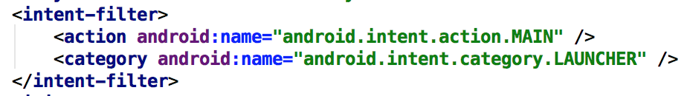
in AndroidManifest.xml if you changed this before.

Exercise 4.2: Show Capital on Map (Currency Converter)
Extend the activity that shows a list of currencies. On click on a list entry there should appear a map (in Google Maps or any other maps app) with the capital of the country shown.
Steps:
- Replace files ExchangeRate.java und ExchangeRateDatabase.java by new variants from the materials for this exercise. The ExchangeRataDatabase.getCapital(String currencyName) returns the capital name.
- Extend CurrencyListActivity with a listener to select an entry. There a fitting Intent is created that starts the Activity for the map view.

Exercise 4.3: Include Share-Button (Currency Converter)
In this exercise you will extend the currency converter with a „share“-button. On selection the current result of the currency conversion can be shared with other apps.
For the App Bar there is a standard approach to include this functionality:
- Add this item to your menu.xml:
<item android:id="@+id/action_share" android:title="Share"
app:showAsAction="ifRoom"
app:actionProviderClass="androidx.appcompat.widget.ShareActionProvider" />

- Extend the method MainActivity.onCreateOptionsMenu() similar to what is shown below:
@Override
public boolean onCreateOptionsMenu(Menu menu) {
getMenuInflater().inflate(R.menu.menu_main, menu);
MenuItem shareItem = menu.findItem(R.id.action_share);
shareActionProvider = (ShareActionProvider)
MenuItemCompat.getActionProvider(shareItem);
setShareText(null);
return true;
}
private void setShareText(String text) {
Intent shareIntent = new Intent(Intent.ACTION_SEND);
shareIntent.setType("text/plain");
if (text != null) {
shareIntent.putExtra(Intent.EXTRA_TEXT, text);
}
shareActionProvider.setShareIntent(shareIntent);
}

- Always call setShareText() to update the share intent when the currency conversion result changes!
- Starting with Android 11 you have to add the following to AndroidManifest.xml to really see all share targets:
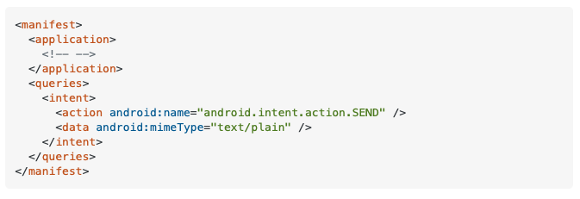

Exercise 4.4: Make Currency List editable (Currency Converter, optional)
Make the currency list editable (similar to the color list during the lecture):
- The currency list has a menu entry to set the list to an „edit mode“.
- On clicking an entry a (new) activity EditCurrencyActivity is started instead of the map from exercise 4.2. In this new activity the currency conversion rate can be edited.
- On finishing the entry the EditCurrencyActivity will be closed and return the new conversion rate.
- This result will be stored in the CurrencyDatabase. Extend the class with the required methods.

See https://stackoverflow.com/a/64777763

